Use-Case Realization Report
Take Lesson

Issue <1.0>
Revision History
Date | Issue | Description | Author
<dd/mmm/yy> | <x.x> | <details> | <name>

Table of Contents
1. Brief Description 4
2. Flow of Events 4
2.1 Standard Flow 4
3. Interaction Diagrams 5
3.1 Collaboration Diagram for Take Lesson 5
4. Participating Objects 5
5. Class Diagrams 6
5.1 Class Diagram for Take Lesson 6
6. Derived Requirements 6

Use-Case Realization Report
Take Lesson

Brief Description

Flow of Events

Standard Flow
- User clicks the link of the lesson to start.
- System will retrieve the last progress of this user, and decide the start point, so that user can resume the study from last point.
- If user never learns this lesson before, the lesson will be started from the 1st page.
- During the process of learning, user can click the navigation button to next or previous page, and the system will retrieve the relevant content and display on the page.
- After user clicks the “Finish” button, his/her current progress will be saved into database for later reference.

Interaction Diagrams

Collaboration Diagram for Take Lesson
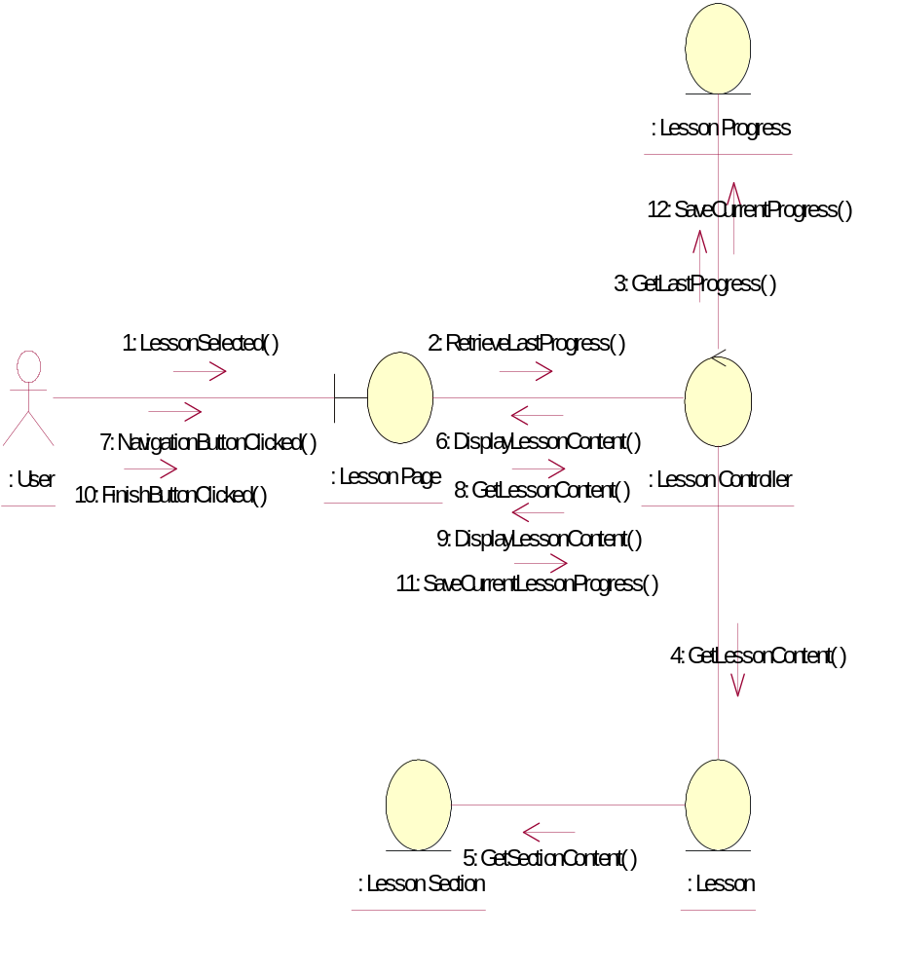

Participating Objects
: Lesson
This entity is the lesson object.
: Lesson Controller
This is the controller to upload, add, delete and modify lessons.
: Lesson Page
This entity will record down the progress made by users on the lessons he/she involved in.
: Lesson Progress
This entity will record down the progress made by users on the lessons he/she involved in.
: Lesson Section
This entity is the Section object
: User
This is the end-user of the system

Class Diagrams

Class Diagram for Take Lesson
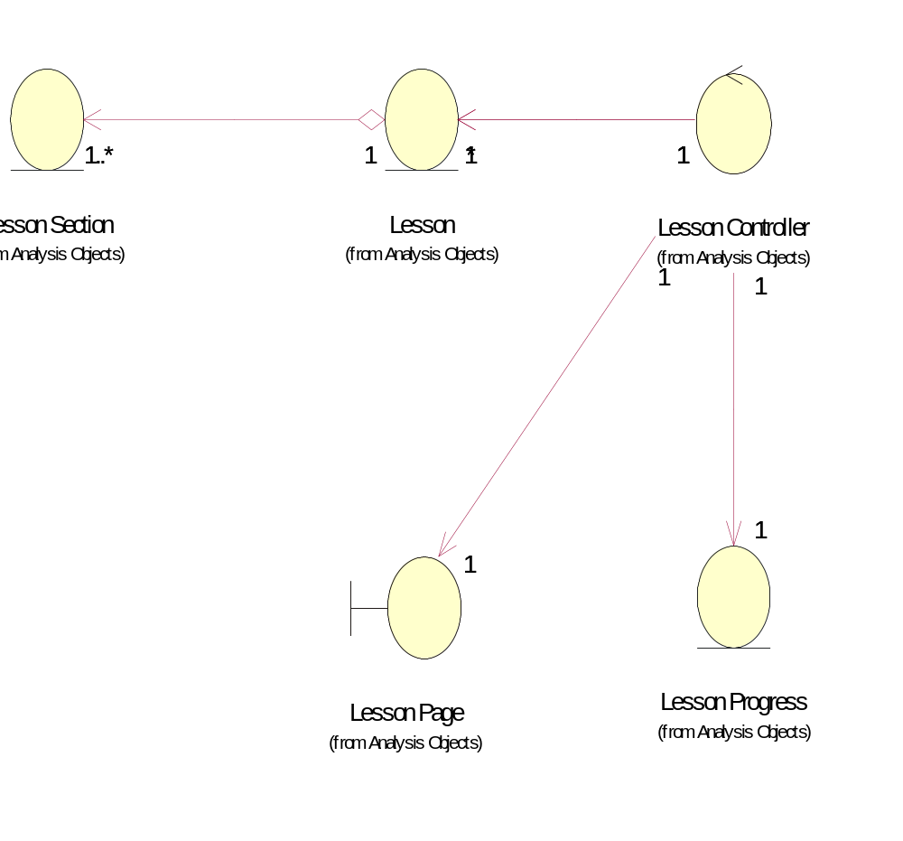

Derived Requirements
No derived requirements.

